1) Configure webhooks to jenkins job.

Webhooks automatically get triggered when there is change in any commits in github

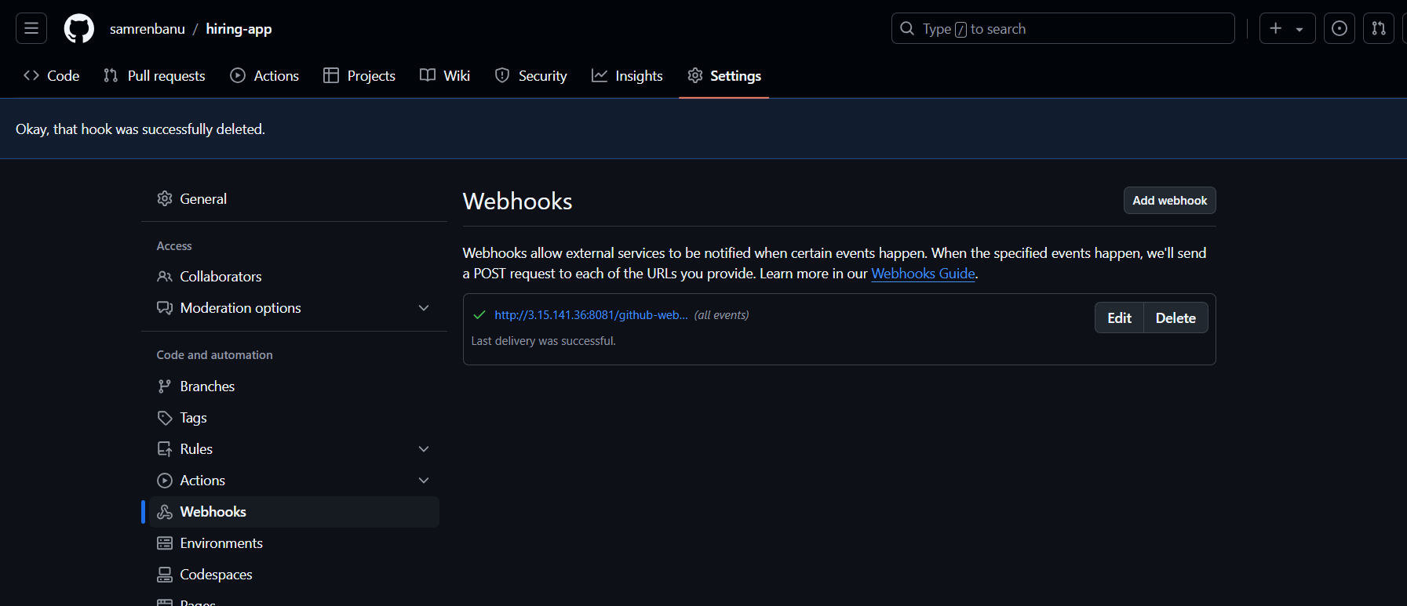

3) Configure poll scm and build periodical options in jenkins job.

Poll scm will check in github if there is any change in one mnt then only this job will get trigger

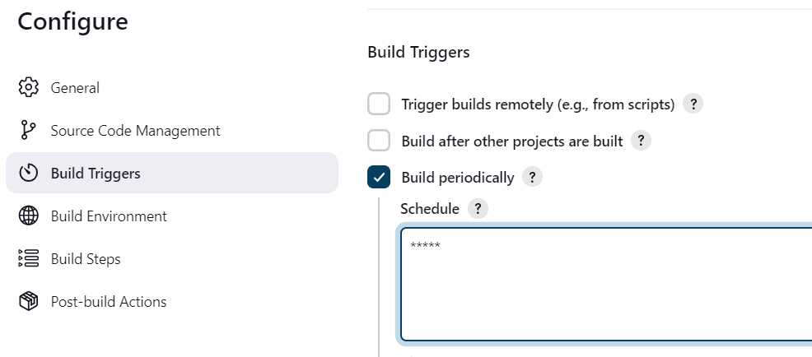

4) Take backup of Jenkins server by using bash script.